Game Name (can be placeholder!)

Key Info
Platform | [e.g. PC VR, iOS, PC, etc. Don’t list platforms unless you know how to develop for them or have factored in time to learn them]
Genre | [e.g. List of video game genres - Wikipedia, list any that make sense and clarify the vision]
Camera Perspective | [e.g. first person, over the shoulder, third person, top down, etc. Popular camera angles used in video games | (behind-the-scenes.net)]
3D or 2D | [2D art or 3D models? Or a mix? Explain briefly if necessary.]
Number of Players | [list all modes that apply: e.g. single player, 4 player co-op, 2v2, etc.]

Short Summary
One to three sentences explaining the game. It is useful to reference existing games / features from existing games to help readers understand.

Key Features / Game Mechanics

Feature Name
Description (1-3 sentences with timestamped video reference if possible.

Feature Name
Description (1-3 sentences with timestamped video reference if possible.

Video References of Comparable titles
Game Title | Takeaway | Video URL
[game title] | [Specific thing in video we should note] | [time stamped URL showing the specific thing]
Legend of Zelda: Breath of the Wild | Player character can climb most surfaces as in Breath of the Wild but our game will have infinite stamina. | https://youtu.be/JbhS4OXWNsE?t=1317
Resident Evil 2 | Camera behavior for walking, running, aiming (2019) | https://youtu.be/UP8h2Wx17fg?t=1963
Okami | You can use comparable title videos here for art direction references too! Just tell us what we should be focusing on.
 | Add as many rows as you need. Remove unused rows.

Controller Map (show the primary / ideal input device)
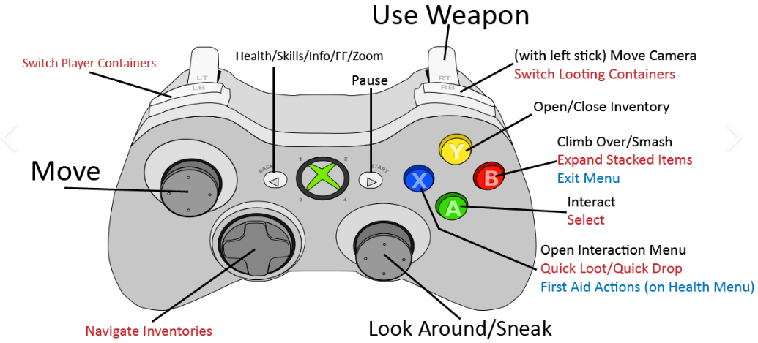

Control Descriptions
Feature | Description | Binding
Move | Basic player movement as in Breath of the Wild. | Left Analog Stick

Walkthrough
Write a gameplay walkthrough of a 1-5 minute sample section of the game. Just like what you'd see on internet FAQs / walkthroughs intended to help understand how to beat actual games that already exist, except you’re making one for your proposed hypothetical game.
Write as though your game is already playable and offer step by step instructions for the player to progress. Tell the player where to go, what to do, and what they should expect.
You don’t need to colorfully describe the environments, characters, or narrative elements. Only describe what players need to understand to progress through the game section.
Use numbered lists and / or subheadings to help keep things clear and concise.
Maps, diagrams, storyboards and mock screenshots are great for helping explain.
Examples
- A New Destination - God of War (2018) Guide - IGN
- Gameplay Layout #1 · dantogno/fancy-footwork Wiki (github.com)

HUD / UI Wireframe
Simple mockup of HUD elements and their size / position.
Placeholder art / standard primitives / wireframe is fine. Add short text that explains what each thing in the screen is.
Digital strongly preferred unless you are a good artist and you have a good way to capture your hand drawing!
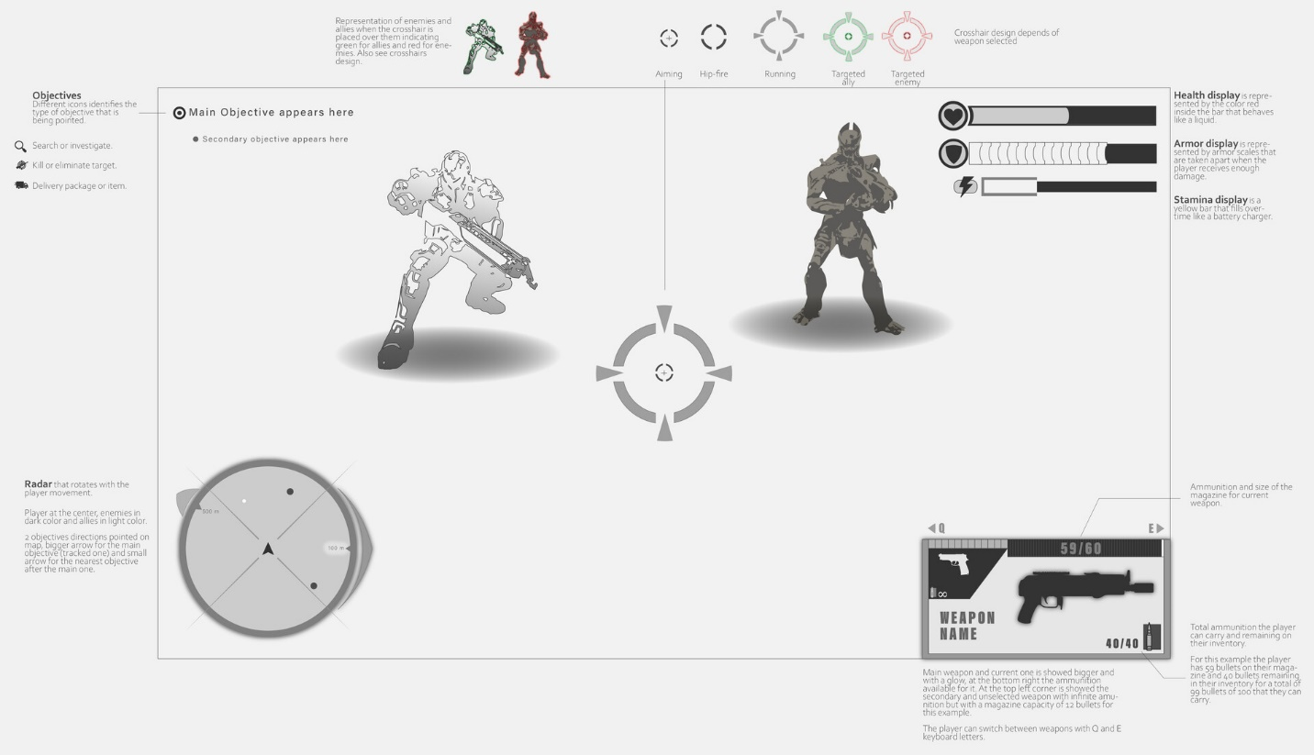

Style Frame / style test
A style frame is a still image used in animation, video production, and game development to visualize the narrative and establish the aesthetic tone of a project. In game development, it should be created in-engine (Unity, Unreal, etc.). It can help uncover technical or art challenges, for instance, if the desired lighting is difficult to accomplish in-engine. It can also reveal if identifying externally created assets will be challenging.
- Guide to Finding Open/Licensable Media Resources for Games
Set up a stationary camera and arrange some art assets that you have access to in the game engine with some lighting, vfx, post processing, etc. to create an idea of what the game should look like. For example, the asset developer Synty often creates fake screenshots of what games could look like using their art assets.
POLYGON | Horror Asylum | Synty™ Official Store – Synty Store
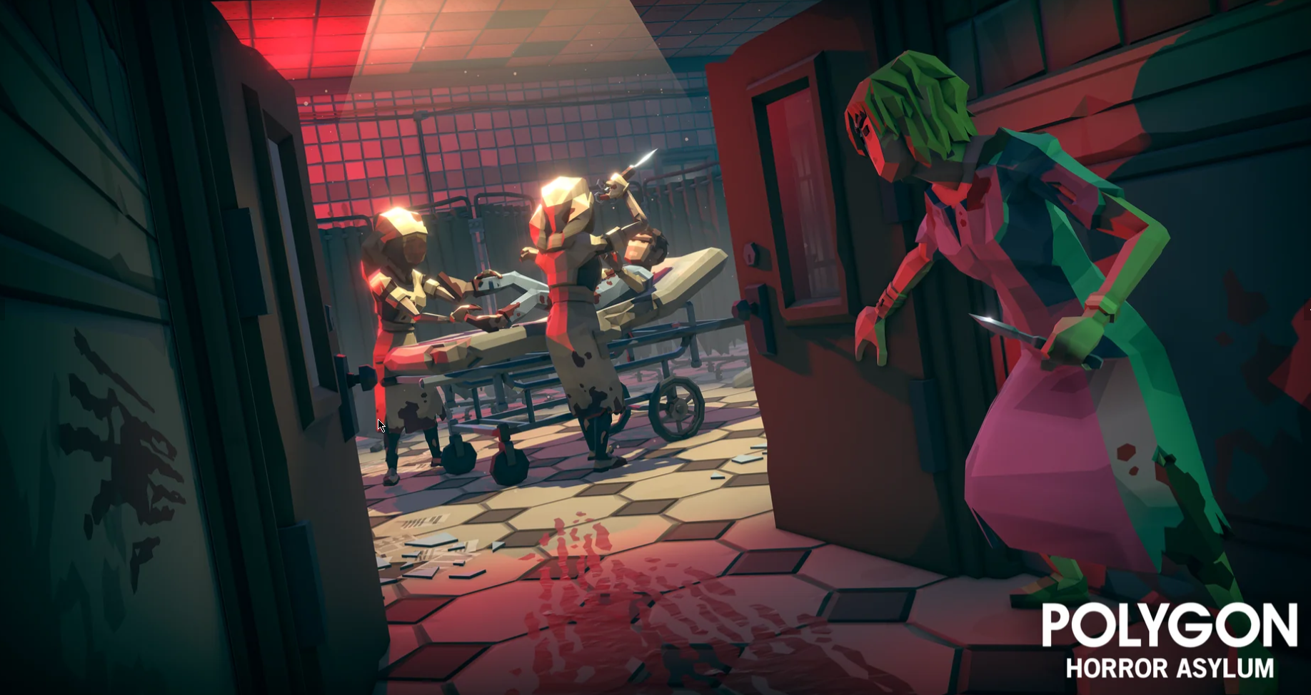
You don’t need any gameplay, just a still image of what the game could look like in engine with a stationary camera view like what you intend to use in the game and example assets and lighting that you arrange in a scene. It doesn’t need to be the final, actual assets you will use. Just reasonable placeholders to convey the concept.
Take a screenshot and add it to this section. Provide links to the assets that you used here as well.

